**CHAPTER-2**

**ANALYTICAL METHODS**

**2.1. ANALYTICAL METHODS**

**2.1.1. UV-Spectrophotometric method for the estimation of clopidogrel bisulphate**

A few among the numerous analytical methods available for the estimation of clopidogrel bisulphate (CBS) are reported and the methods used in the present investigation are described in detail in this section.

**Estimation of clopidogrel bisulphate:** Clopidogrel bisulphate is, chemically methyl (+)-(S)-α-(2-chlorophenyl)-6, 7-dihydrothieno [3, 2-c] pyridine-5(4H) acetate sulphate. The methods available for the estimation are not official methods. Literature review revealed various analytical methods for the determination of CBS earlier are either in single or combination with other drugs analyzed in bulk and pharmaceutical dosage forms. These analytical methods were briefly reviewed below.

# Pravin B C *et al*1 reported on the development and validation of spectrophotometric method for clopidogrel bisulfate in bulk and formulations. **Anandakumar K *et al*2developed a** reverse phase high performance liquid chromatography method was developed for the simultaneous estimation of aspirin and clopidogrel bisulphate in formulation. Lakshmi Prasanna I *etal*3 reported on the spectrophotometric determination of clopidogrel in the presence of asprin (Clopin-A) and its assay by charge-transfer complex method using 2, 3-Dichloro-5, 6-Dicyano-1, 4-Benzoquinone (DDQ). Patel R B *et al*4 carried out studies on simultaneous estimation of acetylsalicylic acid and clopidogrel bisulfate in pure powder and tablet formulations by high-performance column liquid chromatography and high-performance thin-layer chromatography.

**Construction of calibration curve for clopidogrel bisulphate**

A spectrophotometric method based on the measurement of CBS absorbance at 220 nm1, 5 in distilled water, 0.1 N HCl (pH 1.2) and phosphate buffer (pH 6.8) was used in the present study for the estimation of CBS in different samples.

**Preparation of stock solution**

Accurately weighed 100 mg of clopidogrel bisulphate and transferred into a 100mL volumetric flask, few mL of methanol was added to it for complete solubilisation of drug and then the solution was made up to volume with distilled water/0.1 N HCl/ pH 6.8 phosphate buffer to obtain a stock solution of CBS containing 1mg/mL concentration.

**Preparation of standard solution**

The stock solution of CBS was subsequently diluted with respective media i.e., distilled water/ 0.1 N HCl/ pH 6.8 phosphate buffer to obtain a series of standard solutions containing 5, 10, 15, 20, 25, 30, 35, 40 and 45 µg/mL. The absorbance of the standard solutions was measured at 220 nm using UV-VIS spectrophotometer (ELICO, Model SL 210) against respective blanks1, 5. All the estimations were done in triplicate and average values are reported. The concentrations of CBSand their corresponding absorbances are given in **Table 2.1.1.1 to 2.1.1.3**. The absorbance was plotted against concentration ofCBS as shown in **Figure 2.1.1.1 to 2.1.1.3**.

**Table 2.1.1.1: Concentration *vs.* absorbance values for the estimation of CBS in distilled water**

|  |  |
| --- | --- |
| **Concentration (μg/mL)** | **Absorbance\*** |
| 5 | 0.088± 0.003 |
| 10 | 0.200± 0.006 |
| 15 | 0.259± 0.004 |
| 20 | 0.337± 0.003 |
| 25 | 0.453 ± 0.001 |
| 30 | 0.569±0.005 |
| 35 | 0.663±0.003 |
| 40 | 0.747±0.002 |
| 45 | 0.831±0.008 |

* mean ±S.D, n=3

C:\Users\user\Desktop\prasanti Plots\27 Jan 2020\Excel Plots\Excel 2111.emf

**Figure 2.1.1.1: Calibration curve of CBS in distilled water**

**Table 2.1.1.2: Concentration *vs.* absorbance values for the estimation of CBS in**

**0.1N HCl**

|  |  |
| --- | --- |
| **Concentration (μg/mL)** | **Absorbance\*** |
| 5 | 0.084 ± 0.002 |
| 10 | 0.201 ± 0.013 |
| 15 | 0.264 ± 0.005 |
| 20 | 0.349 ± 0.007 |
| 25 | 0.461 ± 0.005 |
| 30 | 0.545 ±0.001 |
| 35 | 0.641±0.003 |
| 40 | 0.725±0.002 |
| 45 | 0.834±0.006 |

* mean ±S.D, n=3

C:\Users\user\Desktop\prasanti Plots\27 Jan 2020\Excel Plots\Excel 2112.emf

**Figure 2.1.1.2: Calibration curve of CBS in 0.1N HCl**

**Table 2.1.1.3: Concentration *vs.* absorbance values for the estimation of CBS**

**in pH 6.8 phosphate buffer**

|  |  |
| --- | --- |
| **Concentration (μg/mL)** | **Absorbance\*** |
| 5 | 0.104 ± 0.005 |
| 10 | 0.206 ± 0.009 |
| 15 | 0.314 ± 0.011 |
| 20 | 0.426 ± 0.008 |
| 25 | 0.510 ± 0.001 |
| 30 | 0.622 ± 0.004 |
| 35 | 0.706 ± 0.003 |
| 40 | 0.791 ± 0.001 |
| 45 | 0.875 ± 0.007 |

* mean ±S.D, n=3

C:\Users\user\Desktop\prasanti Plots\27 Jan 2020\Excel Plots\Excel 2113.emf

**Figure 2.1.1.3: Calibration curve of CBS in pH 6.8 phosphate buffer**

**DISCUSSION**

The method obeyed Beer’s law in the concentration range of 5 to 45 μg/mL. Low RSD (<0.005) values for CBS ensured reproducibility of the method in all the specified media. In order to find the degree of linear relationship, the correlation coefficient (r) was calculated. It was found to be 0.997 in distilled water, 0.999 in 0.1N HCl and 0.998 in pH 6.8 phosphate buffers, which indicated a high degree of positive correlation. Next it was of interest to establish the mathematical form of linear relationship between the two variables i.e., concentration and absorbance under consideration and equation obtained was  **y=0.018x - 0.008** in 0.1 N HCl and **y=0.009x + 0.012** in pH 6.8 phosphate buffer, where x is the concentration of CBS (μg/mL) and y is the absorbance.

**2.1.2. Development of a RP-HPLC method for estimation of CBS in rat plasma**

Literature review revealed various analytical methods for the determination of CBS earlier are either in single or combination with other drugs analyzed in bulk and pharmaceutical dosage forms. These analytical methods were already discussed above.

Pravin B C *et al*1 reported on the development and validation of spectrophotometric method for clopidogrel bisulfate in bulk and formulations. In the present study a reserve phase – High performance liquid chromatography (RP-HPLC) method with UV detection was developed for the estimation of clopidogrel in plasma samples using an external standard method. For this purpose a calibration curve was constructed by analyzing plasma samples containing different amounts of CBS as follows:

**Instrumentation:**

Liquid chromatography method was developed for determination of clopidogrel by using isocratic water alliance 2695 HPLC system equipped with empower version 2.0 software and with UV-visible detector. The separation was achieved on a Phenomenex ODS C18 (250 mm x 4.6 mm, 5 µ) column at ambient temperature. The list of the instruments employed in the study is mentioned in **Table 2.1.2.1.**

**Table 2.1.2.1: Details of the instruments employed in the study**

|  |  |  |
| --- | --- | --- |
| **S. no** | **Equipment** | **Model** |
| 1. | HPLC system | Waters alliance 2695 |
| 2. | UV-Visible spectrophotometer | Waters alliance 2695 |
| 3. | Micro balance | Sartorius |
| 4. | Deep freezer | Cryo scientific (-20ºC) |
| 5. | Refrigerated ultra-centrifuge | Remi |
| 6. | Vacuum pump | Millipore |
| 7. | pHmeter | Orion |
| 8. | Micro pipettes, multi pipettes and micro tips | Brand and eppendorf |
| 9. | Water purification system | Elix 10/ Milli Q gradient |
| 10. | Ultra sonificator | Powersonic 510, (Hwashin technology) |
| 11. | Refrigerator | Samsung |
| 12. | Vortexer | Spinix Torson’s |
| 13. | 5 mL polypropylene | Lotus chemicals |

**Preparation of standard solution:**

Accurately weighed 20.0 mg of clopidogrel was transferred in 10.0mL volumetric flask and added 2.0mL of methanol to dissolve and diluted up to the mark with methanol. The resultant solution was sonicated to dissolve the drug and filtered through 0.22 µm filter membrane. From the filtered solution 5mL was pipetted out and diluted to 10mL with methanol.

**Calibration curve dilutions:**

Different solutions of CBS were prepared from the stock solution (**Table.2.1.2.2**) to get a concentration range of 1.047 – 86.093 μg/mL using the diluents (1:1 mixture of potassium dihydrogen phosphate buffer and acetonitrile. These solutions were further used for spiking the screened blank plasma.

**Table 2.1.2.2: Calibration curve dissolution data for CBS in spiking solution**

|  |  |  |  |  |  |  |
| --- | --- | --- | --- | --- | --- | --- |
| Stock/ SSID | Stock/SS Concentrations  (μg/mL) | Stock/SS Volume  (mL) | Diluent  Volume  (mL) | Total  Volume  (mL) | Final  Conc  (μg/mL) | Spiking solution ID |
| Stock solution | 999.0 | 0.25 | 9.75 | 10 | 361.182 | SS-7 |
| SS-6 | 361.182 | 0.74 | 4.26 | 5 | 86.093 | SS-6 |
| SS-5 | 86.093 | 1.60 | 3.40 | 5 | 60.456 | SS-5 |
| SS-4 | 60.456 | 1.20 | 3.80 | 5 | 37.281 | SS-4 |
| SS-3 | 37.281 | 0.83 | 4.17 | 5 | 22.524 | SS-3 |
| SS-2 | 22.524 | 1.00 | 4.00 | 5 | 9.923 | SS-2 |
| SS-1 | 9.923 | 0.81 | 4.19 | 5 | 1.047 | SS-1 |

**Spiked calibration curve plasma standards:**

The above calibration curve dilutions were used to spike the screened blank rat plasma matrix to prepare the plasma calibration curve standards in the range 52.35 – 4304.456 ng/mL as given in the **Table 2.1.2.3**. Aliquots containing 0.50 mL of the above plasma calibration curve standards were taken in polypropylene vials, labelled properly, tightly closed and stored in a freezer at –700C for further use.

**Table 2.1.2.3: Calibration curve dissolution data for CBS in spiking plasma standards**

|  |  |  |  |  |  |  |
| --- | --- | --- | --- | --- | --- | --- |
| Stock/SSID | Stock/ SS  Concentrations  (μg/mL) | Stock/ SS volume  (mL) | Plasma volume (mL) | Total  Volume  (mL) | Final  Conc  ( μg/mL) | Spiking solution ID |
| SS-6 | 86.093 | 0.50 | 9.50 | 10 | 4.304 | SS-6 |
| SS-5 | 60.456 | 0.50 | 9.50 | 10 | 3.022 | SS-5 |
| SS-4 | 37.281 | 0.50 | 9.50 | 10 | 2.217 | SS-4 |
| SS-3 | 22.524 | 0.50 | 9.50 | 10 | 1.126 | SS-3 |
| SS-2 | 9.923 | 0.50 | 9.50 | 10 | 0.496 | SS-2 |
| SS-1 | 1.047 | 0.50 | 9.50 | 10 | 0.052 | SS-1 |

**Preparation of solutions:**

**Preparation of 0.01M potassium dihydrogen phosphate buffer:**

Accurately weighed 1.36 gm of potaasium dihydrogen orthophosphate transferred in 1000 mL volumetric flask. To this 900 mL of milli Q water was added. The solution was sonicated for 2 minutes and final volume was made up to 1000mL with water. 1 mL of triethylamine was added and pH was adjusted to 3.5 by using dilute orthophosphoric acid solution. The solution was stored at room temperature and used up to three days of preparation.

**Preparation of mobile phase:**

The mobile phase was prepared by mixing 30 parts of buffer solution and 70 parts of acetonitrile in a reagent bottle, sonicated for 5 minutes and filtered through 0.45µ nylon filter. The mobile phase was stored at room temperature and used up to three days of preparation.

**Preparation of diluent:**

A volume of 500 mL of acetonitrile was transferred into 1000 mL reagent bottle and 500 mL of buffer was added to it, mixed and sonicated for 5 minutes. The solution was stored at room temperature and used within seven days from the date of preparation.

**Rinsing solution:**

A volume of 500 mL of acetonitrile was transferred into a 1000 mL reagent bottle; 500 mL of buffer solution was added, mixed and sonicated for 5 minutes. The solution was stored at room temperature and used within seven days from the date of preparation. This solution was used for rinsing the injection needle of the HPLC instrument.

**Method development and optimization of the chromatography conditions:**

For the development of RP-HPLC method for the assay of clopidogrel, different parameters were studied by altering one parameter at a time, keeping all the remaining parameter constant. A non polar Phenomenex ODS C18 (250 mm x 4.6 mm, 5 µ) column was chosen as the stationary phase for this study. The optimized chromatographic conditions are mentioned in **Table 2.1.2.4**.

**Detection of wavelength:**

The UV absorption spectrum was taken and the λ max was found to be at 220 nm. Hence further analysis and detection of drug was carried out at 220 nm.

**The mobile phase and the flow rate:**

In order to get sharp peak and baseline separation of the components, various trials has been taken by using different mobile phases (single solvent or combination of solvents like acetonitrile, water, methanol with or without buffer) on C18 column as a stationary phase. A binary mixture of potassium dihydrogen orthophosphate buffer (pH 3.5) and acetonitrile in a ratio of 30:70 v/v was found to be suitable mobile phase with well defined and well resolved peaks without tailing. A mobile flow rate 0.8 mL/min was found to be suitable when tried in the range of 0.5 to 1.5 mL/min.

**Retention time of CBS:**

A model chromatogram, showing the separation of CBS under the above optimized conditions at a retention time of 4.12 min was obtained as shown in **Figure 2.1.2.2.**

**Data acquisition and processing:**

The chromatograms were obtained and the data was processed by the peak area ratio method using the Empower software. The concentration of the unknown samples was calculated from the following equation of the regression analysis of the spiked plasma calibration graph using 1/X2 as the weighting factor.

**Y= mX+ C**

Where, X= Analyte concentration

Y= Analyte area ratio

m= Slope of the calibration curve

C= Intercept value

**Table 2.1.2.4: Optimized chromatographic conditions**

|  |  |
| --- | --- |
| **Parameter** | **Value** |
| Column | Phenomenex ODS C-18,(250 mm×4.6 mm, 5μm) |
| Mobile phase | Potassium dihydrogen orthophosphate buffer (pH 3.5) and acetonitrile in a ratio of 30:70 v/v |
| Flow rate | 0.8 mL/min |
| Run time | 10 min |
| Column oven temperature | Ambient |
| Auto sampler temperature | 10 ºC |
| Volume of injection | 20 μL |
| Detection of wave length | 220 nm |
| Retention time of CBS | 4.12 min |

**Extraction process of plasma samples and their dying:**

A volume of 400 µL of spiked plasma calibration curve standards was transferred to a set of prelabelled polypropylene tubes. To this 25 µL of CBS (approximately 500 μg/mL) was added and vortexed for 10 seconds. To this 1.2 mL of HPLC grade methanol is added to precipitate the plasma proteins. The samples are then centrifuged for 15 minutes at 4000 rpm in a refrigerated centrifuge. The supernatant is transferred to another set of pre labelled polypropylene tubes and evaporated to dryness under nitrogen at 40ºC. The dried sample is reconstituted with 300 µL of mobile phase, vortex thoroughly and transferred to auto sampler vials for analysis. 20 µL was taken as an injection volume during final analysis.

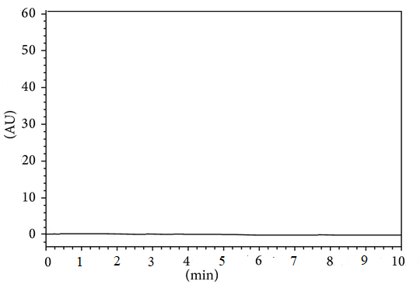

**Figure 2.1.2.1: Chromatogram of extracted blank plasma sample**

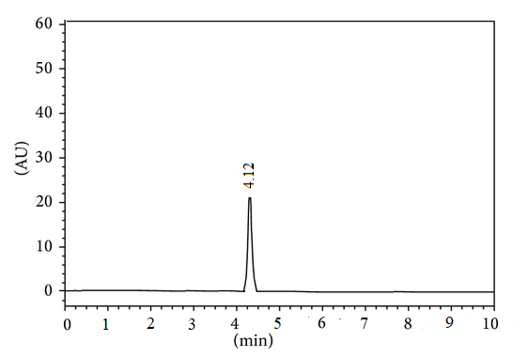

**Figure 2.1.2.2: Chromatogram of clopidogrel with blank plasma**

**Validation of HPLC method:**

**Specificity:**

Specificity of the developed method was validated to check the interference of any compound from formulation matrix. To determine specificity the standard, sample and placebo were injected and the recorded chromatograms are depicted in **Figure 2.1.2.3 to 2.1.2.4**. No peaks were observed at the retention times of CBS under optimized conditions which confirm that the selected drug is evidently allotted and hence the proposed HPLC method is selected.



**Figure 2.1.2.3: Chromatogram of placebo**

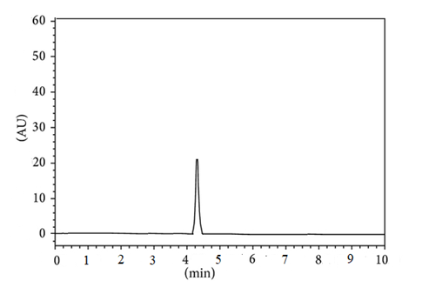

**Figure 2.1.2.4: Chromatogram of standard CBS solution**

**Linearity range:**

The standard concentrations were injected in given range and analyzed according to the developed method. Acceptance of linearity data is judged by examining the calibration curve equation and correlation coefficient (r) and shown in **Table 2.1.2.5 and Figure 2.1.2.6**. The standard solution containing 1000 µg/mL of clopidogrel was prepared and diluted to appropriate concentration from 10-50 µg/mL as a working concentration for each standard 20µL of each solution was injected and analyzed using developed chromatographic method. The chromatograms were recorded and the peak areas of the drug were calculated. The data obtained was subjected to least square regression analysis within microsoft excel to calculate calibration curve equation and correlation coefficient (r). Limit of detection (LOD) and Limit of quantitation (LOQ) were determined from the slope of calibration curve using following formula,

LOD = 3.3σ / S

LOQ = 10 σ / S

Where, σ is the standard deviation of the response

and S is the slope of the calibration curve.

**Table 2.1.2.5: Linearity study of clopidogrel bisulphate**

|  |  |
| --- | --- |
| **Conc (µg/mL)** | **Peak area**  **(μ Volts × min)** |
| 10 | 256291 |
| 20 | 451421 |
| 30 | 606813 |
| 40 | 817032 |
| 50 | 984753 |
| Calibration curve equation | Y=18225X + 7560 |
| Correlation coefficient (r) | 0.998 |
| LOD (µg /mL) | 0.467 |
| LOQ (µg /mL) | 1.752 |

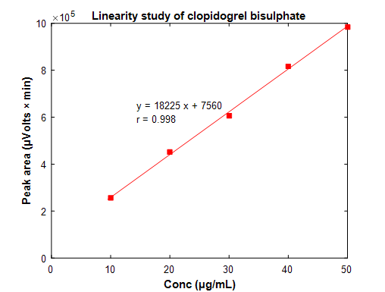

**Figure 2.1.2.5: Linearity study of clopidogrel bisulphate**

**Accuracy:**

The accuracy of method was tested by calculating recoveries of clopidogrel by standard addition method. Correct amount of standard solution each 80%, 100% and 120% were spiked to pre-quantified solution, and the amount of compound recovered and estimated. The results are tabulated in **Table 2.1.2.6**.

**Table 2.1.2.6: Accuracy study of clopidogrel bisulphate**

|  |  |  |  |
| --- | --- | --- | --- |
| **S. No** | **%Concentration**  **(at specification level)** | **% Recovery** | **Mean Recovery%** |
| 1 | 80 | 93.31 | **93.90** |
| 2 | 80 | 94.87 |
| 3 | 80 | 93.53 |
| 4 | 100 | 98.82 | **97.66** |
| 5 | 100 | 97.64 |
| 6 | 100 | 96.58 |
| 7 | 120 | 99.14 | **100.29** |
| 8 | 120 | 100.19 |
| 9 | 120 | 100.02 |

**Precision:**

Precision of an analytical procedure expresses the closeness of agreement between a series of measurements obtained from multiple sampling of the same homogeneous sample under the prescribed conditions.

**Repeatability**

Six replicates of standard mixture were injected and analyzed using optimized method. The average peak area along with the % RSD is shown in the **Table 2.1.2.7**. The % RSD for CBS was found to be 0.89.

**Table 2.1.2.7: Repeatability of clopidogrel bisulphate**

|  |  |
| --- | --- |
| **Parameter** | **Clopidogrel\*** |
| Average Peak area | 2138455 ± 11016 |
| % RSD | 0.89 |

* mean± S.D (n=3)

**Intermediate precision**

Intermediate precision was carried out by intraday and inter day assay method and results were tabulated in **Table 2.1.2.8**. The results showed no significant variation in % RSD of peak area of clopidogrel bisulphate.

**Table 2.1.2.8: Intermediate assay precision of clopidogrel bisulphate**

|  |  |  |
| --- | --- | --- |
| **Compound** | **\*Intra day (%RSD)** | **\*Inter day (% RSD)** |
| Clopidogrel sodium | 1.05 | 0.83 |

**Robustness and ruggedness:**

The robustness of the method was unaffected when small, deliberate changes like, flow change, mobile phase composition, column temperature were performed at 100% test concentration. The ruggedness of the proposed method studied under different columns, analyst and instrument, laboratories analysis of the same sample and method found robust at different conditions and shown in **Table 2.1.2.9**.

|  |  |
| --- | --- |
| **Change in parameters** | **% RSD peak area** |
| Flow rate (0.8 mL/min) | 1.71 |
| Flow rate (1.2 mL/min) | 1.21 |
| Wave length 227 nm | 1.49 |
| Wave length 223 nm | 1.03 |

**Table 2.1.2.9: Robustness study of clopidogrel bisulphate**

**STABILITY STUDY:**

**Forced Degradation stability indicating study:**

#### Preparation of Stock solution:

Transfer accurately about 15 mg clopidogrel into 100 mL volumetric flask, add 60 mL of diluents and dissolve, further make up the volume with diluent to get a working standard solution to 150 μg/mL of CBS.

#### Acidic degradation

A volume of 10 mL of 0.1 N HCl was added to 6 mL of stock solution and was kept at 80 °C for about 24 hrs in water bath, cool made up the volume 50 mL with diluent-2. Filter the solution through 0.22μ membrane filter.

#### Alkali degradation

A volume of 10 mL of 1.0 N NaOH was added to 6 mL of stock solution and was kept at 80 °C for about 72 hrs in water bath, cool made up the volume 50 mL with diluent-2. Filter the solution through 0.22μ membrane filter.

#### Oxidative degradation

A volume of 5 mL of 3% H2O2 added to 6 mL of stock solution and was kept at 80 °C for about 48 hrs in water bath, cool made up the volume 50 mL with diluent-2. Filter the solution through 0.22μ membrane filter.

#### Thermal degradation

Accurately weighed 10 gm of CBS powder was forcibly degraded by exposure to UV Light. The samples were collected after 1st day, 3rd day, 5th day & 10th day. From the degradation studies it was observed that clopidogrel is most sensitive for alkali stress than remaining stress studies as shown in **Table 2.1.2.10.**

**Table 2.1.2.10: Degradation studies of clopidogrel bisulphate**

|  |  |  |  |
| --- | --- | --- | --- |
| **S. No** | **Type of Degradation** | **% Degradation** | **% Recovery** |
| 1 | Acid | 16.40 | 83.53 |
| 2 | Alkali | 16.85 | 83.15 |
| 3 | Hydrolysis | 15.82 | 84.19 |
| 4 | Peroxide | 12.71 | 87.29 |
| 5 | Photo | 14.82 | 85.18 |
| 6 | Reduction | 14.34 | 85.66 |
| 7 | Thermal | 14.05 | 85.95 |

**DISCUSSION**

The RP-HPLC method developed was statistically validated in terms of selectivity, accuracy, linearity, precision, and robustness, stability of solution and mobile phase stability. The chromatograms were recorded for extracted blank sample, CBS with blank sample, placebo and standard CBS solution as shown in **Figure 2.1.2.1 to 2.1.2.4** and the peaks were well separated from each other.

The LOD and LOQ were found to be 0.467μg/mL and 1.752μg/mL, respectively. The linearity results in the specified concentration range are found satisfactory as shown in **Table 2.1.2.5 and Figure 2.1.2.5** and calibration curve was plotted with correlation coefficient (r) 0.998.

Accuracy studies were shown in **Table 2.1.2.6** as % recovery for CBS at 80, 100 and 120%. The limit of % recovered shown is not less than 93% and the results obtained were found to be within the limits. Hence the method was found to be accurate.

For precision studies six replicate injections were performed as shown in **Table 2.1.2.7.** % RSD was determined from peak areas and the results were found to be within the acceptance limits. Intermediate assay precision of CBS is shown in **Table 2.1.2.8** and the results showed no significant variation in % RSD of peak area of clopidogrel bisulphate. The result of the robustness study is shown in **Table 2.1.2.9** and the method was robust at different conditions. Forced degradation studies were performed and the results are shown in **Table 2.1.2.10** and it was observed that clopidogrel is most sensitive for alkali stress than remaining stress studies.

Hence, the chromatographic method developed for CBS is simple, rapid, sensitive, precise and accurate.

**CONCLUSION**

A RP-HPLC method reported in literature was adopted and was modified for the purpose of the present work and was validated as per ICH guidelines. A simple, specific and reliable method reported in the literature was adopted studied by validation for estimation of the CBS. The total run time was 10 minutes where clopidogrel got separated at 4.12 minutes. There was no interference of any other peak with clopidogrel peak. When the same sample containing clopidogrel was injected 6 times, it did not affect the retention time of the drug. The developed method was validated for intraday and inter day variations. The results indicated that the reported method is highly specific and reproducible. Hence, it was concluded that the reported method may be used in the formulation development of the selected drug candidate, namely clopidogrel bisulphate.

**2.2. ANALYTICAL METHODS OF DOLUTEGRAVIR SODIUM**

**2.2.1. UV-Spectrophotometric method for the estimation of dolutegravir sodium**

A few among the numerous analytical methods available for the estimation of dolutegravir sodium are reported and the methods used in the present investigation are described in detail in the section.

**Estimation of dolutegravir sodium:** Dolutegravir sodium, is chemically (3S,7R)-N-[(2,4-diflurophenyl)methyl]-11-hydroxy-7-methyl-9,12-dioxo-4-oxa-1,8-diazatricyclo,tetradeca-10,13-diene;13-carboxide. The methods available for the estimation are not official methods. Literature review revealed various analytical methods for the determination of DTG earlier are either in single or combination with other drugs analyzed in bulk and pharmaceutical dosage forms. These analytical methods were briefly reviewed below.

Balasaheb *et al*6 reported a UV-spectrophotometric method for estimation of dolutegravir sodium in tablet dosage form. Masthanamma *et al*7 reported a novel UV-Spectrophotometric method for the development and validation of dolutegravir in bulk and its laboratory synthetic mixture. Naresh and Nagaraju8 reported UPLC method for simultaneous estimation of abacavir, lamivudine and dolutegravir from its tablet dosage form. Joseph *et al*9 reported a RP-HPLC method for the estimation of dolutegravir and rilpivirine in both bulk and pharmaceutical dosage form. Talari Kalpana *et al*10 reported a RP-HPLC method for determination of dolutegravir sodium, lamivudine and tenofovir disoproxil fumarate. Rajkumar *et al*11 reported a RP-HPLC method for the determination of lamivudine, abacavir and dolutegravir in pharmaceutical dosage forms. Devanna N *et al*12 reported a method for the simultaneous estimation of dolutegravir and lamivudine in drug product by RP-HPLC.

**2.2.1. UV-Spectrophotometric method for the estimation of dolutegravir sodium**

**Construction of calibration curve for dolutegravir sodium**

A spectrophotometric method based on the measurement of DTG absorbance at 258 nm6 in distilled water, 0.1 N HCl (pH 1.2) and phosphate buffer (pH 6.8) was used in the present study for the estimation of DTG in different samples.

**Preparation of stock solution**

Accurately weighed 100 mg of dolutegravir sodium and transferred into a 100 mL volumetric flask, few mL of methanol was added to it for complete solubilisation of drug and then the solution was made up to volume with distilled water/ 0.1 N HCl/ pH 6.8 phosphate buffer to obtain a stock solution of DTG containing 1mg/mL concentration.

**Preparation of standard solution**

The stock solution of DTG was subsequently diluted with respective media i.e., distilled water/ 0.1 N HCl/ pH 6.8 phosphate buffer to obtain a series of standard solutions containing 5, 10, 15, 20, 25, 30, 35 and 40 µg/mL. The absorbance of the standard solutions was measured at 258 nm using UV-VIS spectrophotometer (ELICO, Model SL 210) against respective blanks6, 7.All the estimations were done in triplicate and average values are reported. The concentrations of DTGand their corresponding absorbances are given in **Table 2.2.1.1** to **2.2.1.3**. The absorbance was plotted against concentration ofDTG as shown in **Figure 2.2.1.1** to **2.2.1.3**.

**Table 2.2.1.1: Concentration *vs.* absorbance values for the estimation of DTG in distilled water**

|  |  |
| --- | --- |
| Concentration (μg/mL) | Absorbance* |
| 5 | 0.125 ± 0.004 |
| 10 | 0.232 ± 0.002 |
| 15 | 0.345 ± 0.003 |
| 20 | 0.443 ± 0.005 |
| 25 | 0.529 ± 0.001 |
| 30 | 0.610 ± 0.008 |
| 35 | 0.687 ± 0.002 |
| 40 | 0.794 ± 0.005 |

* mean ±S.D, n=3

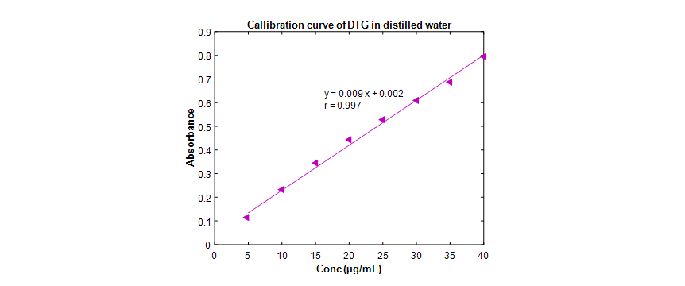

**Figure 2.2.1.1: Calibration curve of DTG in distilled water**

**Table 2.2.1.2: Concentration *vs.* absorbance values for the estimation of DTG in**

**0.1N HCl**

|  |  |
| --- | --- |
| Concentration (μg/mL) | Absorbance* |
| 5 | 0.139 ± 0.005 |
| 10 | 0.239 ± 0.002 |
| 15 | 0.332 ± 0.004 |
| 20 | 0.453 ± 0.005 |
| 25 | 0.561 ± 0.008 |
| 30 | 0.635 ± 0.009 |
| 35 | 0.710 ± 0.004 |
| 40 | 0.794 ± 0.003 |

* mean ±S.D, n=3

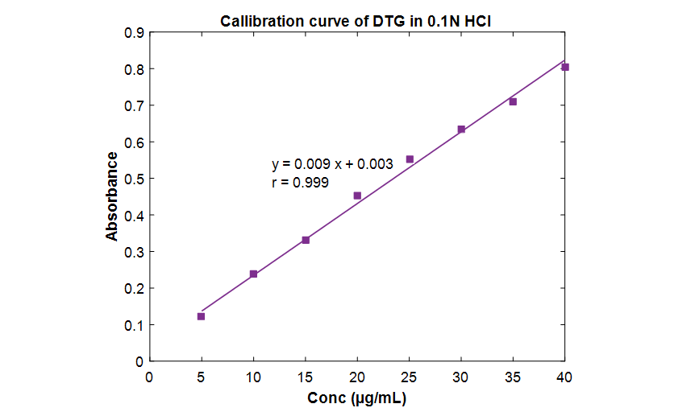

**Figure 2.2.1.2: Calibration curve of DTG in 0.1N HCl**

**Table 2.2.1.3: Concentration *vs.* absorbance values for the estimation of DTG in pH 6.8 phosphate buffer**

|  |  |
| --- | --- |
| Concentration (μg/mL) | Absorbance* |
| 5 | 0.088 ± 0.002 |
| 10 | 0.178 ± 0.003 |
| 15 | 0.281 ± 0.004 |
| 20 | 0.412 ± 0.009 |
| 25 | 0.535 ± 0.005 |
| 30 | 0.650 ± 0.008 |
| 35 | 0.768 ± 0.001 |
| 40 | 0.854 ± 0.002 |

* mean ±S.D, n=3

C:\Users\user\Desktop\prasanti Plots\27 Jan 2020\Excel Plots\Excel 2213.emf

**Figure 2.2.1.3: Calibration curve of DTG in pH 6.8 phosphate buffer**

**DISCUSSION**

This method has obeyed Beer’s law in the concentration range of 5 to 40 μg/mL. Low RSD (<0.005) values of DTG indicated the reproducibility of the method in all the specified media. In order to find the degree of linear relationship, the correlation coefficient was calculated. It was found to be **0.996** in distilled water, **0.998** in 0.1N HCl and **0.999** in pH 6.8 phosphate buffers, which indicated a high degree of correlation. Next it was of interest to establish the mathematical form of linear relationship between the two variables i.e., concentration and absorbance under consideration and equation obtained was **y=0.009x + 0.003** in 0.1 N HCl and **y=0.011x - 0.003** for pH 6.8 phosphate buffer, where x is the concentration of DTG (μg/mL) and y is the absorbance.

**2.2.2. Development of a RP-HPLC method for estimation of DTG in rat plasma**

Literature review revealed that various analytical methods for the determination of DTG earlier are either in single or in combination with other drugs analyzed in bulk and pharmaceutical dosage forms. These analytical methods were already discussed above. Devanna N *et al*12 reported a method for the simultaneous estimation of dolutegravir and lamivudine in drug products by RP-HPLC. In the present study this reported reserve phase – High performance liquid chromatography (RP-HPLC) method with UV detection was adopted for the estimation of dolutegravir in plasma samples. It was further studied by validation. For this purpose a calibration curve was constructed by analyzing plasma samples containing different amounts of DTG as follows:

**Instrumentation**

Liquid chromatography method was developed for determination of dolutegravir by using isocratic water alliance 2695 HPLC system equipped with empower version 2.0 software and with UV-visible detector. The separation was achieved on a Phenomenex ODS C18 (250 mm x 4.6 mm, 5 µ) column at ambient temperature. The list of the instruments employed in the study is mentioned in **Table 2.2.2.1**.

**Table 2.2.2.1: Details of the instruments employed in the study**

|  |  |  |
| --- | --- | --- |
| **S. no** | **Equipment** | **Model** |
| 1. | HPLC system | Waters alliance 2695 |
| 2. | UV-Visible spectrophotometer | Waters alliance 2695 |
| 3. | Micro balance | Sartorius |
| 4. | Deep freezer | Cryo scientific (-20ºC) |
| 5. | Refrigerated ultra-centrifuge | Remi |
| 6. | Vacuum pump | Millipore |
| 7. | pHmeter | Orion |
| 8. | Micro pipettes, multi pipettes and micro tips | Brand and eppendorf |
| 9. | Water purification system | Elix 10/ Milli Q gradient |
| 10. | Ultra sonificator | Powersonic 510, (Hwashin technology) |
| 11. | Refrigerator | Samsung |
| 12. | Vortexer | Spinix Torson’s |
| 13. | 5 mL polypropylene | Lotus chemicals |

**Preparation of standard solution**

Accurately weighed 20.0 mg of dolutegravir was transferred in 10.0mL volumetric flask and added 2.0mL of methanol to dissolve and diluted up to the mark with methanol. The resultant solution was sonicated to dissolve the drug and filtered through 0.22 µm filter membrane. From the filtered solution 5 mL was pipetted out and diluted to 10 mL with methanol.

**Calibration curve dilutions**

Different solutions of DTG were prepared from the stock solution (**Table 2.2.2.2**) to get a concentration range of 1.11 - 101.65 μg/mL using the diluents (1:1 mixture of potassium dihydrogen phosphate buffer and acetonitrile. These solutions were further used for spiking the screened blank plasma.

**Table 2.2.2.2: Calibration curve dissolution data for DTG in spiking solution**

|  |  |  |  |  |  |  |
| --- | --- | --- | --- | --- | --- | --- |
| Stock/ SSID | Stock/SS Concentrations  (μg/mL) | Stock/SS Volume  (mL) | Diluent  Volume  (mL) | Total  Volume  (mL) | Final  Conc  (μg/mL) | Spiking solution ID |
| Stock solution | 999.00 | 0.37 | 9.63 | 10 | 369.63 | SS-7 |
| SS-6 | 369.63 | 1.26 | 3.740 | 5 | 93.147 | SS-6 |
| SS-5 | 93.147 | 0.900 | 4.100 | 5 | 66.533 | SS-5 |
| SS-4 | 66.533 | 0.600 | 4.400 | 5 | 44.356 | SS-4 |
| SS-3 | 44.356 | 0.400 | 4.600 | 5 | 29.570 | SS-3 |
| SS-2 | 29.570 | 0.200 | 4.800 | 5 | 14.785 | SS-2 |
| SS-1 | 14.785 | 0.030 | 4.970 | 5 | 2.218 | SS-1 |

**Spiked calibration curve plasma standards**

The above calibration curve dilutions were used to spike the screened blank rat plasma matrix to prepare the plasma calibration curve standards in the range 110.889 – 4657.338 ng/mL as given in the **Table 2.2.2.3**. Aliquots containing 0.50 mL of the above plasma calibration curve standards were taken in polypropylene vials, labelled properly, tightly closed and stored in a freezer at –700C for further use.

**Table 2.2.2.3: Calibration curve dissolution data for DTG in spiking plasma standards**

|  |  |  |  |  |  |  |
| --- | --- | --- | --- | --- | --- | --- |
| Stock/SSID | Stock/ SS  Concentrations  (μg/mL) | Stock/ SS volume  (mL) | Plasma volume (mL) | Total  Volume  (mL) | Final  Conc  ( μg/mL) | Spiking solution ID |
| SS-6 | 93.147 | 0.50 | 9.50 | 10 | 4.657 | SS-6 |
| SS-5 | 66.533 | 0.50 | 9.50 | 10 | 3.326 | SS-5 |
| SS-4 | 44.356 | 0.50 | 9.50 | 10 | 2.217 | SS-4 |
| SS-3 | 29.570 | 0.50 | 9.50 | 10 | 1.478 | SS-3 |
| SS-2 | 14.785 | 0.50 | 9.50 | 10 | 0.739 | SS-2 |
| SS-1 | 2.218 | 0.50 | 9.50 | 10 | 0.110 | SS-1 |

**Preparation of solutions**

**Preparation of 0.01M potassium dihydrogen phosphate buffer**

Accurately weighed 1.36 gm of potaasium dihydrogen orthophosphate was transferred into a 1000 mL volumetric flask. To this 900 mL of milli Q water was added. The solution was sonicated for 2 minutes and the final volume was made up to 1000mL with water. One mL of triethylamine was added and the pH was adjusted to 3.0 by using dilute orthophosphoric acid solution. The solution was stored at room temperature and was used up to three days after preparation.

**Preparation of mobile phase**

The mobile phase was prepared by mixing 25 parts of buffer solution and 75 parts of acetonitrile in a reagent bottle. It was sonicated for 5 minutes and was filtered through a 0.45µ nylon filter. The mobile phase was stored at room temperature and was used up to three days after preparation.

**Preparation of diluent**

A volume of 500 mL of acetonitrile was transferred into 1000 mL reagent bottle and 500 mL of buffer was added to it, mixed and sonicated for 5 minutes. The solution was stored at room temperature and used within seven days from the date of preparation.

**Rinsing solution**

A volume of 500 mL of acetonitrile was transferred into a 1000 mL reagent bottle; 500 mL of buffer solution was added, it was mixed and sonicated for 5 minutes. The solution was stored at room temperature and was used within seven days from the date of preparation. This solution was used for rinsing the injection needle of the HPLC instrument.

**Method validation and optimization of the chromatography conditions**

For the purpose of this research project a reported RP-HPLC method (Devanna *et al*12)was taken and was studied by validation studies. Different parameters were studied by altering one parameter at a time, keeping all the remaining parameters constant. A non polar Phenomenex ODS C18 (250 mm x 4.6 mm, 5 µ) column was chosen as the stationary phase for this study. The optimized chromatographic conditions are mentioned in **Table 2.2.2.4**.

**Detection of wavelength**

The UV absorption spectrum was taken and the λ max was found to be at 258 nm. Hence, further analysis and detection of the drug was carried out at 258 nm.

**The mobile phase and the flow rate**

In order to get a sharp peak and baseline separation of the components, various trials have been taken by using different mobile phases (single solvent or combination of solvents like acetonitrile, water, methanol with or without buffer) on C18 column as a stationary phase. A binary mixture of potassium dihydrogen orthophosphate buffer (pH 3 ± 0.05) and acetonitrile in a ratio of 25:75 v/v was found to be suitable mobile phase with well defined and well resolved peaks without tailing. A mobile flow rate 1.0 mL/min was found to be suitable when tried in the range of 0.5 to 1.5 mL/min.

**Retention time of DTG**

A model chromatogram, showing the separation of DTG under the above optimized conditions at a retention time of 4.78 min was obtained as shown in **Figure 2.2.2.5**.

**Data acquisition and processing**

The chromatograms were obtained and the data was processed by the peak area ratio method using the Empower software. The concentration of the unknown samples was calculated from the following equation of the regression analysis of the spiked plasma calibration graph using 1/X2 as the weighting factor.

**Y= mX+ C**

Where, X= Analyte concentration

Y= Analyte area ratio

m= Slope of the calibration curve

C= Intercept value

**Table 2.2.2.4: Optimized chromatographic conditions**

|  |  |
| --- | --- |
| **Parameter** | **Value** |
| Column | Phenomenex ODS C-18,(250 mm×4.6 mm, 5μm) |
| Mobile phase | Potassium dihydrogen orthophosphate buffer (pH 3 ± 0.05) and acetonitrile in a ratio of 25:75 v/v |
| Flow rate | 1.0 mL/min |
| Run time | 7 min |
| Column oven temperature | Ambient |
| Auto sampler temperature | 10 ºC |
| Volume of injection | 20 μL |
| Detection of wave length | 258 nm |
| Retention time of DTG | 4.78 min |

**Extraction process of plasma samples and their dying**

A volume of 400 µL of spiked plasma calibration curve standards was transferred to a set of prelabelled polypropylene tubes. To this 25 µL of DTG (approximately 500 μg/mL) was added and vortexed for 10 seconds. To this 1.2 mL of HPLC grade methanol is added to precipitate the plasma proteins. The samples are then centrifuged for 15 minutes at 4000 rpm in a refrigerated centrifuge. The supernatant is transferred to another set of pre labelled polypropylene tubes and evaporated to dryness under nitrogen at 40ºC. The dried sample is reconstituted with 300 µL of mobile phase, vortex thoroughly and tr ansferred to auto sampler vials for analysis. 20 µL was taken as an injection volume during final analysis.

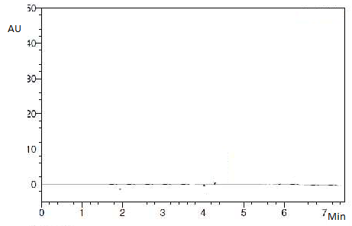

**Figure 2.2.2.1: Chromatogram of extracted blank plasma sample**

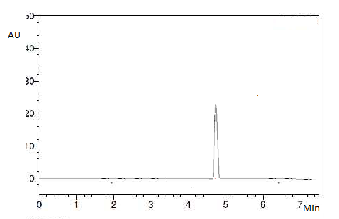

4.78

**Figure 2.2.2.2: Chromatogram of dolutegravir with blank plasma**

**Validation of HPLC method**

**Specificity**

Specificity of the developed method was validated to check the interference of any compound from formulation matrix. To determine specificity the standard, sample and placebo were injected and the recorded chromatograms are depicted in **Figure 2.2.2.3 to 2.2.2.5**. No peaks were observed at the retention times of DTG under optimized conditions which confirm that the selected drug is evidently allotted and hence the proposed HPLC method is selected.



**Figure 2.2.2.3: Chromatogram of placebo**



**Figure 2.2.2.4: Chromatogram of standard DTG solution**

**Linearity range**

The standard concentrations were injected in given range and analyzed according to the method. Acceptance of linearity data is judged by examining the calibration curve equation and correlation coefficient (r) and shown in **Table 2.2.2.5 and Figure 2.2.2.5**. The standard solution containing 1000 µg/mL of dolutegravir was prepared and diluted to appropriate concentration from 10-50 µg/mL as a working concentration for each standard 20µL of each solution was injected and analyzed using developed chromatographic method. The chromatograms were recorded and the peak areas of the drug were calculated. The data obtained was subjected to least square regression analysis within microsoft excel to calculate calibration curve equation and correlation coefficient (r). Limit of detection (LOD) and Limit of quantitation (LOQ) were determined from the slope of calibration curve using following formula,

LOD = 3.3σ / S

LOQ = 10 σ / S

Where, σ is the standard deviation of the response

and S is the slope of the calibration curve.

**Table 2.2.2.5: Linearity study of dolutegravir sodium**

|  |  |
| --- | --- |
| **Conc (µg/mL)** | **Peak area**  **(μ Volts × min)** |
| 10 | 219519 |
| 20 | 368131 |
| 30 | 597321 |
| 40 | 793218 |
| 50 | 987497 |
| Calibration curve equation | Y=19679X + 2297 |
| Correlation coefficient (r) | 0.998 |
| LOD (µg /mL) | 0.638 |
| LOQ (µg /mL) | 1.933 |

C:\Users\user\Desktop\prasanti Plots\27 Jan 2020\Excel Plots\Excel 2225.emf

**Figure 2.2.2.5: Linearity study of dolutegravir sodium**

**Accuracy**

The accuracy of the method was tested by calculating recoveries of dolutegravir by standard addition method. Correct amount of standard solution each 50%, 100% and 150% were spiked to pre-quantified solution, and the amount of compound recovered and estimated. The results are tabulated in **Table 2.2.2.6**.

**Table 2.2.2.6: Accuracy study of dolutegravir sodium**

|  |  |  |  |
| --- | --- | --- | --- |
| **S. No** | **%Concentration**  **(at specification level)** | **% Recovery** | **Mean Recovery%** |
| 1 | 50 | 94.93 | **95.15** |
| 2 | 50 | 95.58 |
| 3 | 50 | 94.93 |
| 4 | 100 | 101.19 | **100.09** |
| 5 | 100 | 99.26 |
| 6 | 100 | 99.83 |
| 7 | 150 | 96.50 | **96.47** |
| 8 | 150 | 96.63 |
| 9 | 150 | 96.28 |

**Precision**

Precision of an analytical procedure expresses the closeness of agreement between a series of measurements obtained from multiple sampling of the same homogeneous sample under the prescribed conditions.

**Repeatability**

Six replicates of standard mixture were injected and analyzed using optimized method. The average peak area along with the % RSD is shown in the **Table 2.2.2.7**. The % RSD for DTG was found to be 0.98.

**Table 2.2.2.7: Repeatability of dolutegravir sodium**

|  |  |
| --- | --- |
| **Parameter** | **Dolutegravir\*** |
| Average Peak area | 1916046 ± 18811 |
| % RSD | 0.98 |

* mean± S.D (n=3)

**Intermediate precision**

Intermediate precision was carried out by intraday and inter day assay method and results were tabulated in **Table 2.2.2.8**. The results showed no significant variation in % RSD of peak area of dolutegravir sodium.

**Table 2.2.2.8: Intermediate assay precision of dolutegravir sodium**

|  |  |  |
| --- | --- | --- |
| **Compound** | **\*Intra day (%RSD)** | **\*Inter day (% RSD)** |
| Dolutegravir sodium | 1.25 | 0.96 |

**Robustness and ruggedness**

The robustness of the method was unaffected when small, deliberate changes like, flow change, mobile phase composition, column temperature were performed at 100% test concentration. The ruggedness of the method was studied under different columns, analyst and instrument, laboratories analysis of the same sample and the method was found to be robust at different conditions and shown in **Table 2.2.2.9**.

|  |  |
| --- | --- |
| **Change in parameters** | **% RSD peak area** |
| Flow rate (0.9 mL/min) | 1.4 |
| Flow rate (1.1 mL/min) | 1.2 |
| Wave length 255 nm | 1.5 |
| Wave length 261 nm | 1.2 |

**Table 2.2.2.9: Robustness study of dolutegavir sodium**

**STABILITY STUDY**

**Forced Degradation stability indicating study**

#### Preparation of Stock solution

About 15 mg of dolutegravir was transferred into a 100 mL volumetric flask, 60 mL of diluents were added, and dissolved; further the volume was made up with the diluent to get a working standard solution to 150 μg/mL of DTG.

#### Acidic degradation

A volume of 10 mL of 0.1 N HCl was added to 6 mL of stock solution and was kept at 80 °C for about 24 hrs in water bath, cool made up the volume 50 mL with diluent-2. Filter the solution through 0.22μ membrane filter.

#### Alkali degradation

A volume of 10 mL of 1.0 N NaOH was added to 6 mL of stock solution and was kept at 80 °C for about 72 hrs in water bath, cool made up the volume 50 mL with diluent-2. Filter the solution through 0.22μ membrane filter.

#### Oxidative degradation

A volume of 5 mL of 3% H2O2 added to 6 mL of stock solution and was kept at 80 °C for about 48 hrs in water bath, cool made up the volume 50 mL with diluent-2. Filter the solution through 0.22μ membrane filter.

#### Thermal degradation

Accurately weighed 10 gm of DTG powder was forcibly degraded by exposure to UV Light. The samples were collected after 1st day, 3rd day, 5th day & 10th day. From the degradation studies it was observed that dolutegravir is most sensitive for alkali stress than remaining stress studies as shown in **Table 2.2.2.10**.

**Table 2.2.2.10: Degradation studies of dolutegravir sodium**

|  |  |  |  |
| --- | --- | --- | --- |
| **S. No** | **Type of Degradation** | **% Degradation** | **% Recovery** |
| 1 | Acid | 17.37 | 82.63 |
| 2 | Alkali | 18.88 | 81.12 |
| 3 | Hydrolysis | 18.00 | 82.00 |
| 4 | Peroxide | 18.69 | 81.31 |
| 5 | Photo | 18.11 | 81.89 |
| 6 | Reduction | 18.34 | 81.66 |
| 7 | Thermal | 17.46 | 82.54 |

**DISCUSSION**

A RP-HPLC method which was reported in literature was adopted, suitably modified and was validated in terms of selectivity, accuracy, linearity, precision, and robustness, stability of solution and mobile phase stability. The chromatograms were recorded for extracted blank sample, DTG with blank sample, placebo and standard DTG solution as shown in **Figures 2.2.2.1 to 2.2.2.4** and the peaks were well separated from each other.

The LOD and LOQ were found to be 0.638 μg/mL and 1.933μg/mL, respectively. The linearity results in the specified concentration range are found satisfactory as shown in **Table 2.2.2.5 and Figure 2.2.2.5** and calibration curve was plotted with correlation coefficient (r) 0.998.

Accuracy studies were shown in **Table 2.2.2.6** as % recovery for DTG at 50, 100 and 150%. The limit of % recovered shown is not less than 95% and the results obtained were found to be within the limits. Hence the method was found to be accurate.

For precision studies six replicate injections were performed as shown in **Table 2.2.2.7.** % RSD was determined from peak areas and the results were found to be within the acceptance limits. Intermediate assay precision of DTG is shown in **Table 2.2.2.8** and the results showed no significant variation in % RSD of peak area of dolutegravir sodium. The result of the robustness study is shown in **Table 2.2.2.9** and the method was robust at different conditions. Forced degradation studies were performed and the results are shown in **Table 2.2.2.10** and it was observed that dolutegravir is most sensitive for alkali stress than remaining stress studies.

Hence, the chromatographic method developed for DTG is simple, rapid, sensitive, precise and accurate.

**CONCLUSION**

A RP-HPLC method reported in literature was adopted and was modified for the purpose of the present work and was validated as per ICH guidelines. A simple, specific and reliable method reported in the literature was adopted studied by validation for estimation of the DTG. The total run time was 7 minutes where dolutegravir got separated at 4.78 minutes. There was no interference of any other peak with dolutegravir peak. When the same sample containing dolutegravir was injected 6 times, it did not affect the retention time of the drug. The developed method was validated for intraday and inter day variations. The results indicated that the reported method is highly specific and reproducible. Hence, it was concluded that the reported method may be used in the formulation development of the selected drug candidate, namely dolutegravir sodium.

**REFERENCES**

1. Pravin C, Ingale Y N, Gopale A S, Jadhav K and Chemate S Z. Development and validation of spectrophotometric method for clopidogrel bisulfate in bulk and formulations, International Journal of Chemical Sciences, 2012; 10(1): 449-456.

# **Anandakumar K, Ayyappan T, Raghu Raman V, Vetrichelvan T, Sankar A S K and Nagavalli D.** [RP-HPLC analysis of aspirin and clopidogrel bisulphate in combination](http://www.ijpsonline.com/articles/rphplc-analysis-of-aspirin-and-clopidogrel-bisulphate-in-combination.html), Indian Journal of Pharmaceutical Sciences, 2007; 69(4): 597-599.

1. Lakshmi Prasanna I, Naidu G T, Fathima N, Chakravathy I E and Abdul Huq G. Spectrophotometric determination of clopidogrel in the presence of asprin (clopin - A) benzoquinone (DDQ), International Journal of Pharmacy and Pharmaceutical Research, 2018; 12 (2): 138-147.
2. Patel R B, Shankar M B, Patel M R and Bhatt K K. Simultaneous estimation of acetylsalicylic acid and clopidogrel bisulfate in pure powder and tablet formulations by HPLC and HPTLC. Journal of AOAC International, 2008; 91(4): 750-755.
3. Antypenko L, Gladysheva S and Vasyuk S. Development and validation of clopidogrel bisulphate determination in bulk by UV spectrophotometric method, Scripta Scientifica Pharmaceutica, 2016; 3(2): 17-22.
4. Bhavar Girija B, Aher Kiran B, Ravindra Subhash T, Jijabapu K and Sanjay Sudhakar P. Development and validation of UV- spectrophotometric method for estimation of dolutegravir sodium in tablet dosage form, Malaysian Journal of Analytical Sciences, 2015; 19(6): 1156 - 1163.
5. Masthanamma S K, Vasundhara K, Srilakshmi S and Fathimabi S K. A novel UV-spectrophotometric method development and validation of dolutegravir in bulk and its laboratory synthetic mixture, American Journal of PharmTech Research, 2016; 6(3): 258-265.
6. Naresh N and Nagaraju P. Stability indicating UPLC method for simultaneous estimation of abacavir, lamivudine and dolutegravir from its tablet dosage form, World Journal of Pharmaceutical Sciences, 2015; 3(10): 2135-2140.
7. Jomol J, Hepsebah N J R and Deepthi K. Analytical method development and validation for the simultaneous estimation of dolutegravir and rilpivirine using rphplc method in both bulk and pharmaceutical dosage form, European Journal of Biomedical and Pharmaceutical Sciences, 2016; 3(5): 237-243.
8. Rajkumar P, Ganapathy S, Vamsi Krishna P and Surendra Babu L. RP-HPLC method development and validation for the simultaneous determination of lamivudine, abacavir and dolutegravir in pharmaceutical dosage forms, World Journal of Pharmaceutical Sciences, 2017; 5(5): 168-181.
9. Devanna N, Dudekula B and Ramachandraiah C. Development and validation for the simultaneous estimation of dolutegravir and lamivudine in drug product by RP-HPLC, International Journal of Research in Pharmaceutical and Nano Sciences,2017; 6(4): 173 - 180.